* **[How to edit a list or library using Quick Edit](https://sharepoint.rackspace.com/learning/articles/Pages/SharePoint-2013--how-to-edit-a-list-or-library-using-Quick-Edit.aspx)**

1. From the home page of your SharePoint site, open any list or library you would like, in this example I will open my “Documents” library.

2. Click LIBRARY to expand the ribbon.

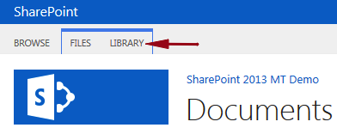

3. On the ribbon in the View Format section click **Quick Edit**.  
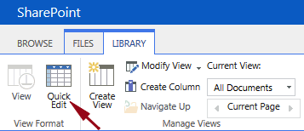

The “Documents” library will now be opened in Quick Edit view and I can easily edit multiple items.  This makes editing multiple items very simple.

4. I will edit the “Client Notes” documen. In the Purpose column, click the drop-down and select “**Meeting Notes**”.

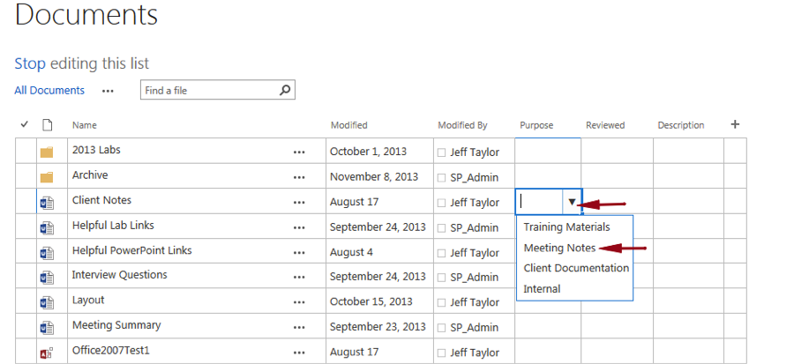  
  
5. In the Reviewed column click the drop-down and select “**Yes**”.  
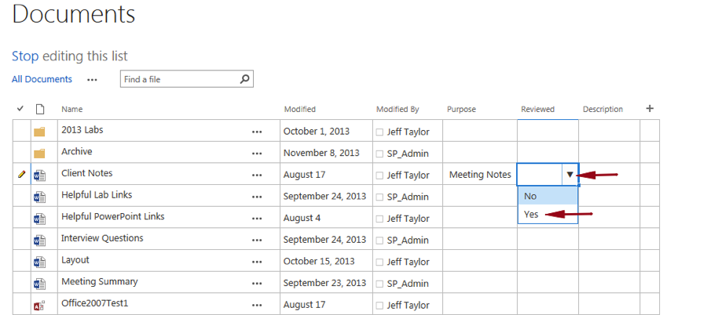

6. To update multiple items at once, similar to Excel, hover your mouse over the lower right   
corner of a field with data, click and drag across multiple items.  
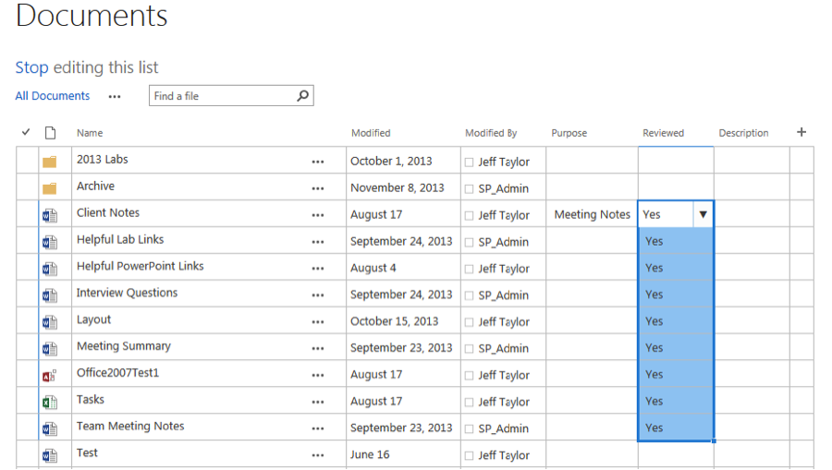

7. To save your changes click **Stop**, editing this list.

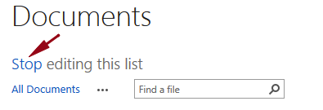

That was almost too easy!

